The Cost of Global Warming

Tony Noerpel

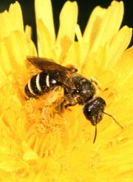
A decade ago we moved to Loudoun County, Virginia. As a former amateur beekeeper, I observed hundreds of different types of domestic and wild honeybees feeding off my Rose of Sharon, Lamb’s Ear and other flowering plants. Every year since, I’ve observed a decline in both the number of bees and the number of different types of bees. My unscientific backyard census has since been confirmed by many scientific papers, including, most recently, a paper published in the proceedings of the National Academy of Sciences by Vamosi [Vamosi]. This paper reports that populations of all pollinators are in decline and many species are at risk of extinction because of anthropogenic environmental degradation. I haven’t yet seen a paper linking bee species extinction directly with anthropogenic global warming (AGW), but global warming itself is only one of several negative consequences of human activity.

The Vamosi paper projects extensive extinction of flowering plants as a result of pollinator extinction. The direct impact to human life is that over 30% of all our food production is dependent on pollinator activity, i.e. humans require the services of pollinators in agriculture. Nature provides this service for free. This allows us to put a well-defined lower limit on the cost of our environmental destruction. There would obviously be a cost associated with having to perform this function on our own. Most importantly, it takes energy.

Replacing this food with new technology is not practical. In fact, the gains in production due to what has been called the “green revolution” are illusory. We are destroying soil ecology by the overuse of fossil fuel derived fertilizer, pesticides and herbicides. There is evidence that transgenic crops are contributing to the decline of pollinators [Giles].

Species extinction is not limited to pollinators. E. O. Wilson, in his 2002 book “The Future of Life”, estimates that 50% of all plants and animals will be extinct by 2100. Since about 500 million years ago, the average rate of species extinction has been about 1 per million per year. Of course there have been mass extinction events like the Permian extinction which occurred 250 million years ago and the K-T extinction which eliminated the dinosaurs about 65 million years ago and there have been long periods of relative tranquility. Wilson estimates that current species extinction is between 1,000 and 10,000 species per million per year. At this rate, the current anthropogenic species extinction event will be among the six worse extinction events of all time and may rival the Permian extinction, which eliminated between 90 and 95% of all species [Benton].

Assuming mid-range IPCC global warming scenarios, Thomas et al. project between 17 and 35% of all species will become extinct by 2050 [Thomas]. In addition to pollinators, species such as trees, coral reefs, fish, fungus, soil bacteria and plankton which directly benefit humans and without which we cannot survive, and species such as the polar bear and the prairie dog are under assault by human activity. This result shows that we are on track to match Wilson’s estimate. Further, Thomas’ result may be conservative because the 2001 IPCC report did not take into account methane release from melting permafrost in Alaska and Siberia. Early indications are that the next IPCC report will increase the estimated anthropogenic climate change.

It is naïve to assume that humans can survive an extinction event that wipes out as much as 50% of all other species. We are perhaps the most complex life form and most dependent on the rest of the inhabitants of the biosphere. While we pride ourselves on our adaptability and our technological prowess, there are limits to adaptability and our technology is causing most of our problems.

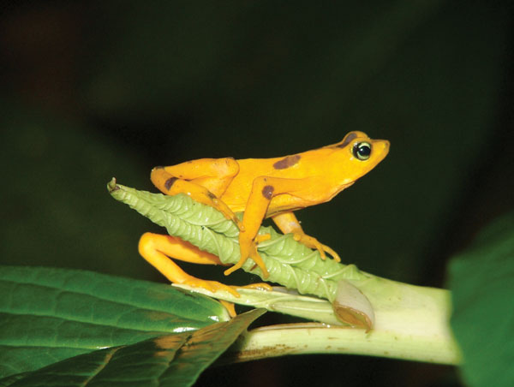
Similar to my informal bee population observation, I have observed a decline in the local population of amphibians on my property. This, too, has been confirmed in the scientific literature as a worldwide phenomenon. Most recently in an article published in Nature by Pound [Pound] (see also [Blaustein]) this extinction event has been directly attributable to global warming. Amphibians control mosquitoes and other pests. As they become extinct, we could replace this service too, but at a cost.

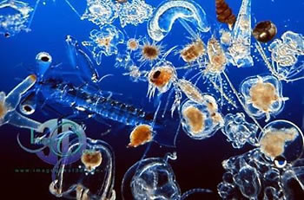
Perhaps more disturbing, Schmittner has hypothesized that phytoplankton are also threatened by global warming and might collapse to less than half their current boimass [Schmittner]. These species render profoundly essential services to humans for free. Phytoplankton are an important driver of the carbon cycle upon which all life on Earth depends. The oceans have absorbed about half of the excess carbon dioxide, we have been admitting into the atmosphere, about 500 Gigatons since the start of the industrial revolution, reducing the anthropogenic global warming forcing by about half. Plankton have been taking up much of this carbon. Phytoplankton are at the bottom of the food chain for all other ocean life forms on which we depend. This service can be measured economically in terms of the cost of carbon sequestration equipment which would have to be installed world-wide to absorb several Gigatons of carbon per year and the cost of replacing fish and mollusks as food sources.

We depend on watersheds for fresh water. Forests and glaciers contribute a free service to human survival by moderating water. As global warming melts glaciers and as human activities destroy forests, we will be required to provide these services artificially in order to survive. Artificial engineering methods of providing and purifying fresh water require expensive infrastructure and energy in the construction of dams, reservoirs and purification plants.
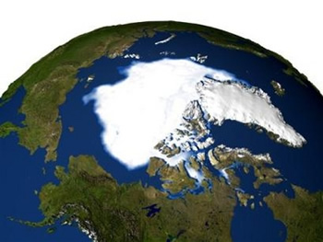
Glacier melt raises ocean levels and freshens the North Atlantic. When the ice on Greenland and Antarctica melt, ocean levels will increase by several tens of meters. Several billion people will have to be relocated inland. While most scientists have assumed that this rise will take centuries to occur, in fact, measurements are exceeding projections.

A paper by Bryden [Bryden] suggests that the freshening of the North Atlantic may have resulted in a slowdown of the Gulf Stream circulation by as much as 30% since the 1950’s.

Hurricane frequency and intensity will also require us to depopulate coastal regions. Several breakthrough papers have been published in the fall of 2005 demonstrating the link between hurricane frequency and intensity to Anthropogenic Global Warming (see for example [Emanuel]). Oil and natural gas structures in the Gulf of Mexico, for example, will have to be redesigned and rebuilt. All of this will have a cost associated with it.

Anthropogenic destruction of forests is both a climate forcing and a positive feedback contributor to global warming. By cutting down forests, we eliminate land-based carbon sinks for sequestering atmospheric carbon dioxide. We are increasing atmospheric carbon dioxide and as a result causing an increase in global temperature, by both replacing forests with agriculture and by burning fossil fuels. This rapid climate change encourages the spread of destructive pests such as bark beetles, which, in turn, destroy even more forests.

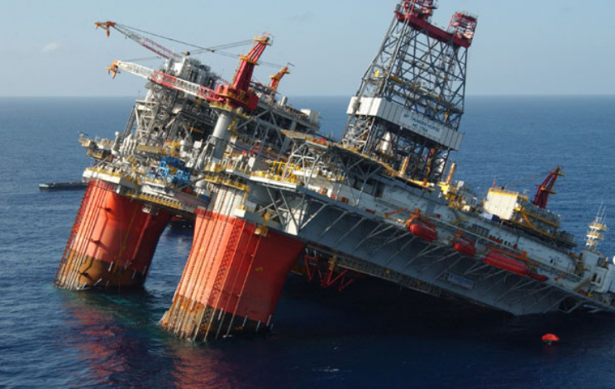
Over fishing has depleted ocean and fresh water fish stocks. This was essentially free food provided by nature for our benefit. We now have to replace this valuable source of protein at a cost. Related to destruction of ocean fisheries is the destruction of coral reefs through pollution and Anthropogenic Global Warming.

Other costs include loss of diversity, which is difficult to measure and soil depletion. With respect to soil destruction, we are already using vast quantities of artificial fertilizers that use natural gas as a feedstock.

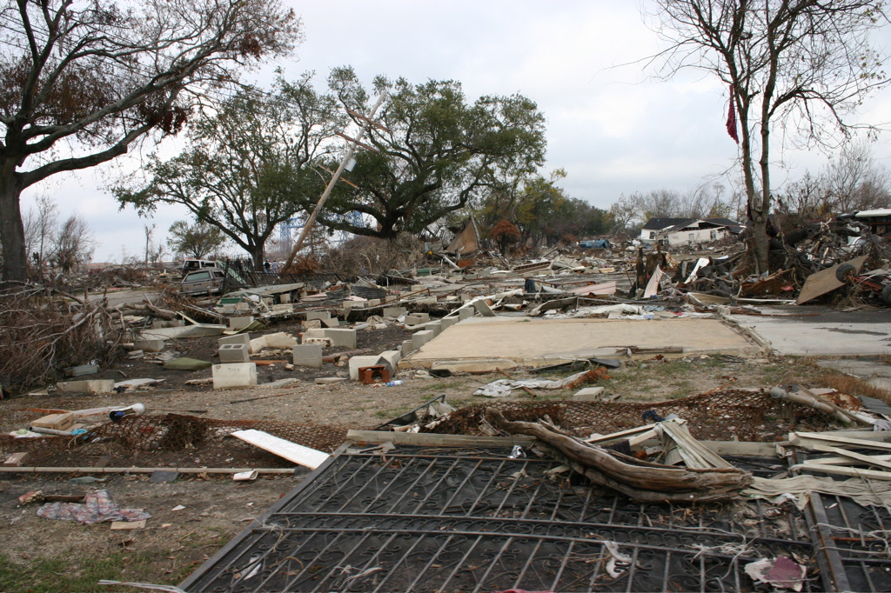
Given the experience of New Orleans, it is unreasonable to assume that humans will proactively tackle these problems in a cost effective manner. We need to be reminded that the cost of adequately rebuilding the levees before Katrina would have been about $2.5 Billion and this item was routinely removed from the budgets approved by congress and the President. Instead, the cost to rebuild New Orleans will be at least one hundred times that. Even after Katrina, our leaders are only discussing re-engineering the levees to withstand category 3 hurricanes and not the category 4 and 5 hurricanes that will surely be more frequent in the future. Nobody is discussing moving New Orleans to higher ground or redesigning the levees to repair the Louisiana wetlands.

Assuming mid-range IPCC global warming scenarios, Thomas et al. project between 17 and 35% of all species will become extinct by 2050 [Thomas]. In addition to species such as trees, pollinators, coral reefs, fish and plankton which directly benefit humans and without which we cannot survive, all species are under assault by human activity. Unless we modify our economy and society rather drastically and elect responsible leaders, and do this rather quickly, it is unlikely humans will survive. To be blunt, without pollinators, forests, coral reefs, phytoplankton and soil bacteria and fungus, it is unlikely we can continue to exist on Earth.

The cost of reducing carbon emissions has to be weighed against the cost of having to artificially replace all the services which nature is currently providing for free. Then of course the reality is that the cost of reducing carbon emissions and modifying our society, i.e., giving up on a growth-based economy and transitioning to a sustainable economy, is manageable. However, the cost of replacing naturally provided services is most likely not physically possible.

It is ironic that the Bush administration is reluctant to address human caused environmental degradation or even admit that there is such a thing because they don’t want to negatively impact the US economy, yet their economic policies are destroying the US economy anyway. It is interesting to observe that total US credit market debt is now 304% of GDP and this compares unfavorably with the 287% of GDP at the start of the Great Depression. The GINI coefficient for the US is now .462 a level not seen since 1932. The savings rate in the US during 2005 was negative for the first time since 1932. However, the US economy in 1932 enjoyed several distinct advantages with our current economy. Oil was cheap and plentiful. The US was the world’s swing producer and oil cost $.10 a barrel. Today the US is the world’s largest importer and has an enormous dependency on oil. The US had a trade surplus in 1932 but the largest trade deficit in human history today. A depression has to be considered likely.

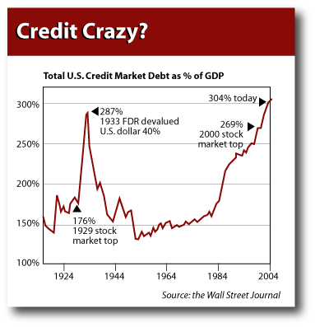
Exponential economic growth is only possible with exponential growth in exploitation of new energy sources. We cannot grow our way out of our current economic problems. This may explain why our current growth is coming at the expense of increasing debt, increasing inequality, increasing environmental deterioration and inflation, which are all growing faster than the economy. The best measure of our societal deterioration is infant mortality rate because pregnant women and small children are most vulnerable to negative cultural changes. The US infant mortality rate increased for the first time in almost 60 years in 2003 and is today worse than Cuba, a country that is unfairly suffering the impact of the ill-advised US trade sanctions and embargo.

The US federal debt is unprecedented and is caused by excessive military spending, tax cuts for the wealthy and subsidies to large multinational corporations. We have been bankrupted by supply side economic theories at the very time when we need to be investing in public health, the environment, education and alternative energy. Our current accounts deficit now requires us to borrow close to $3 Billion a day from foreigners.

It is not the relatively modest cost of ameliorating Anthropogenic Global Warming and implementing Kyoto and beyond which should concern our leaders, but the overwhelmingly huge costs of ignoring AGW that should be considered. There is little point in claiming to preserve an economy that is being destroyed, anyway. As a point of fact, nobody has successfully demonstrated that implementing Kyoto actually is a net cost. That it may be is largely just another myth like Iraq’s WMD, or supply side economic theory.

The costs of our current policy of ignoring the problem include the loss of much of our food supply due to decline in the population of pollinators, loss of soil fertility, loss of fresh water, loss of fossil fuels as feedstock for fertilizer and pesticides and loss of ocean and fresh water fish stocks. The cost droughts and heat waves and of relocating more than half of the human population away from low lying coastal areas out of harms way of rising ocean levels and devastating hurricanes needs to be considered as well. Against these costs, the cost of implementing of Kyoto is insignificant.

[Benton] Michael J. Benton “When Life Nearly Died”, Thames and Hudson, 2003.

[Blaustein] Blaustein and Dobson, “Extinctions: A Message From The Frogs” Nature 439, 143-144, 12 January 2006

[Bryden] Bryden, Longworth, and Cunningham, “Slowing of the Atlantic meridional overturning circulation at 25° N,”Nature 438, 655-657 (1 December 2005)

[Emanuel] Emanuel, “Increasing destructiveness of tropical cyclones over the past 30 years,” Nature 436, 686-688 (04 Aug 2005).

[Giles] Giles, Nature News, “Transgenic crops take another knock, Shift in weed species hits bees and butterflies, Published online: 21 March 2005.

[Pound] Pound et al., “Widespread amphibian extinctions from epidemic disease driven by global warming,” Nature 439, 161-167 (12 January 2006)

[Schmittner] A. Schmittner Decline of the marine ecosystem caused by a reduction in the Atlantic overturning circulation”, Nature 434, 628-633 (31 March 2005)

[Thomas] Thomas et al., “Extinction risk from climate change’, Nature 427, 145-148 (8 January 2004)

[Vamosi] Vamosi, Knight, Steets, Mazer, Burd and Ashman, “Pollination decays in biodiversity hotspots”, Proceedings of the National Academy of Science, January 24 2006, vol. 103, no. 4, 956-961

